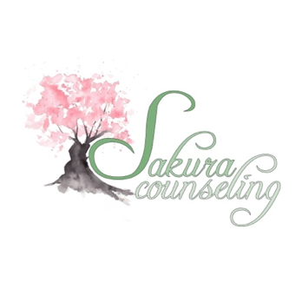

Sakura Counseling 2025-2026 Associate & Licensed Application
Thank you for your interest in the Counseling position at Sakura Counseling. We look forward to learning more about you throughout the application and interview process!
We are seeking motivated individuals who are eager to learn, be collaborative, practice humility, welcome humor, grow, and support community members in their therapy journey. We hope that this position will help you to continue deeping your skills, inspire you, and provide you with the practical experience necessary to continue bridging the gap between academic knowledge and real-world application.
As you prepare your application, we encourage you to reflect on your passion for counseling, your academic achievements, and any relevant experiences that have shaped your journey in this field. We look forward to learning about your unique perspectives and how you envision contributing to and benefiting from our company.
We hope to welcome some of you to our team soon!

Application Checklist:
Review Sakura’s expectations for therapists to make sure we are a good fit.

Fill out application and written responses (outlined below)

Email completed Application Process, Resume, and Cover Letter to mika.dalton@sakuracounseling.org (please make sure to include ALL needed documents to be considered for a position)

The Admin Team will review your applications and reach out to schedule an interview

Associate & Licensed Application
Name:
Pronouns (if comfortable sharing):
Email (best email to receive application updates to):
Phone Number:
Licensure Level: Registered Associate Licensed
Licensure Type: LPC CSW MFT Other (please specify)
Do you have any extended breaks where you will not be able to see clients? (If yes, please share the dates of this break):
When are you hoping to start:
Which day(s) & time(s) works best to attend the official interview? (Select all that apply)
Mon Tues Wed Thurs Fri
Morning (8am-12:00pm) Afternoon (12:00pm-4:00pm)

Written Responses
Please take some time to tell us a bit more about your work as a current clinician.
*All responses should be kept to a maximum of 400 words per question*
- While we see a majority of QTBIPOC clients here, how might your identities impact your work with clients from different backgrounds?

- What inspired you to become a therapist and how did this draw you to working at Sakura Counseling?

- How do you respond to and integrate feedback from a supervisor/mentor? How do you advocate for yourself when you have had challenges with a supervisor, professor, or colleague?
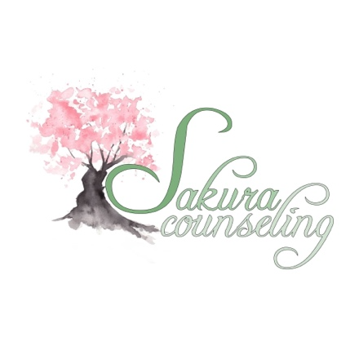

- Can you describe your ideal supervisory/mentorship experience that strengthens, challenges, and expands your counseling identity?

- What do you feel will be the challenges for you working hybrid with a focus of telehealth?

